**Academic Performance Analysis**

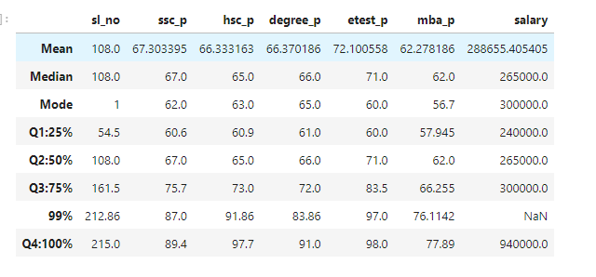

**Understanding Key Statistical Terms:**

* **Mean**: The **average score** across all students.
* **Median**: The middle value in the sorted list of scores.
* **Mode**: The most frequently occurring score.
* **Percentile**: Represents the value below which a given percentage of observations in a dataset fall. For example, the 25th percentile (Q1) means 25% of the data points are below this value.
* **Q1: 25%:** The 25th percentile score, also known as the first quartile.
* **Q2: 50%:** The 50th percentile score, which is **the same as the median.**
* **Q3: 75%:** The 75th percentile score, also known as the third quartile.
* **Q4: 100%:** The maximum score.

**Quartile Differences and Percentage Increases**

**SSC Percentage (ssc_p):**

* **Q2 - Q1:** 6.4 points (10.56% increase)
  + Q2 = 67.0, Q1 = 60.6
  + **Difference** = Q2 - Q1 = 67.0 - 60.6 = **6.4 points**
  + **Percentage Increase** = (6.4/60.6) * 100=**10.56% increase**
* **Q3 - Q2:** 8.7 points (12.99% increase)
* **Q4 - Q3:** 13.7 points (18.10% increase)

**HSC Percentage (hsc_p):**

* **Q2 - Q1:** 4.1 points (6.73% increase)
* **Q3 - Q2:** 8 points (12.31% increase)
* **Q4 - Q3:** 24.7 points (33.84% increase)

**Degree Percentage (degree_p):**

* **Q2 - Q1:** 5 points (8.20% increase)
* **Q3 - Q2:** 6 points (9.09% increase)
* **Q4 - Q3:** 19 points (26.39% increase)

**E-test Percentage (etest_p):**

* **Q2 - Q1:** 11 points (18.33% increase)
* **Q3 - Q2:** 12.5 points (17.61% increase)
* **Q4 - Q3:** 14.5 points (17.37% increase)

**MBA Percentage (mba_p):**

* **Q2 - Q1:** 4.055 points (7% increase)
* **Q3 - Q2:** 4.255 points (6.86% increase)
* **Q4 - Q3:** 11.635 points (17.56% increase)

**Salary:**

* **Q2 - Q1:** 25,000 units (10.42% increase)
* **Q3 - Q2:** 35,000 units (13.21% increase)
* **Q4 - Q3:** 640,000 units (213.33% increase)

**Summary**

**1. Academic Performance Trends:**

* **SSC, HSC, Degree Percentages:**
  + Scores consistently increase across quartiles, indicating an upward trend in academic performance.
  + The HSC percentage shows a sharp increase of 33.84% from Q3 to Q4, indicating a significant jump for top performers in this metric.
  + The Degree percentage has a steady increase across quartiles, with the largest jump (26.39%) from Q3 to Q4.
* **E-test Percentage:**
  + Exhibits the highest variability across quartiles with an 18.33% increase from Q1 to Q2 and a notable 17.37% jump from Q3 to Q4. This indicates that the E-test differentiates well between lower and higher performers.
* **MBA Percentage:**
  + Shows the smallest increases compared to other academic metrics, suggesting less variation in performance among students. The highest increase (17.56%) occurs between Q3 and Q4.

**2. Salary Distribution:**

* **Salary increases sharply between quartiles**:
  + Minimal increase of 10.42% from Q1 to Q2, and 13.21% from Q2 to Q3.
  + A dramatic jump of 213.33% from Q3 to Q4 indicates that top earners (100th percentile) receive significantly higher salaries than others, pointing to possible premium positions or roles.

**3.** **Key Observations:**

* **Top Performers Distinction:**
  + Significant jumps in the highest quartile (Q4) indicate a clear distinction between top performers and others, especially in HSC, Degree, and E-test scores.
* **High Salary Variability:**
  + A substantial increase in salary between Q3 and Q4 suggests that exceptional academic performance or other factors (like job role or experience) dramatically impact earnings.

**Overall Insight:**

The data shows a diverse range of performance across all metrics. The most significant differences are observed in the highest quartile (Q4), where top performers excel academically and command substantially higher salaries. The sharp salary increase suggests that a few individuals at the top substantially outperform the rest, both academically and financially.